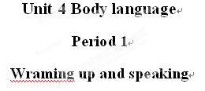
Teaching Goals:
1. Teach the students how to understand body language used in different countries or cultures as well as in different occasions.
2. Teach the students how to use body language in the most appropriate occasions.
Teaching Procedures:
Step 1. Lead-in
body language plays a very important part in our life. We are all healthy people, sometimes we can use body language to express ourselves. So we should pay more attention to learning body languages.
Step 2. Introduction
let’s do some TPR (Total Physical Response) activities together.
Touch your head / face / eyes / nose / mouth / ears / cheeks / forehead / shoulders / stomach / legs / feet / toes ... Shake your head / arm / hand ...
Step 3. Practice
Look at Page 25. What are these people communicating?
Step 4. Homework
1. Team work: Discuss the importance of body language.
2. Go over the Reading:
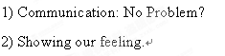


Teaching Goals:
1. Enable the students to realize the importance of body language.
2.Help the students learn how to explain the common idea—“different cultures, different body languages” with the target language in this unit.
Teaching Procedures:
Step1. Revision
Free talk about the topic: the Importance of Body Language.
Step 2. Pre-reading
discuss these questions with your partner:
1. What is the purpose of language?
2. How can you tell if someone is sad even if they do not speak?
3. What would you do if you need the other’s help urgently while you two speak different languages?
4. Give an example of how you can communicate a feeling to someone who does not speak your language.
Step 3. While-reading
1. Scanning
While reading, please try to divide the whole passage into several parts and find out the main idea.
2.Read the text carefully, then decide if the following statements are true or false
Step 4. Post reading
1. Is the author of this passage male or female? How do you know ?
2.What were the two mistakes that the author noticed?
3. Who seemed to prefer to keep more physical distance from others? Who seemed to prefer closer physical distance ?
4. Did any students have similar greeting customs? If so, which ones?
5. “ When in Rome, do as the Romans do.” What do you think this famous saying means?
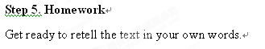
Step1 presentation
Structure Study
一: V-ing 形式由 “do＋ing” 构成, 其否定形式是 “not doing”, V-ing 可以带宾语或状语构成 V-ing 短语, 没有人称和数的变化, 但有时态和语态的变化。
V-ing 形式在句中作定语和状语是本单元的学习重点。
1. 作定语
V-ing 形式可以单独充当名词的前置修饰语, 这时有两种情况。
- -ing形式表示 “供作......之用”的意思, 这类作定语的-ing形式过去叫动名词。
A swimming pool
= a pool for swimming
2) -ing形式表示 “......的” 意思, 过去叫现在分词
A sleeping child
working people
the rising sun
-ing形式短语作定语时一般放在它所修饰的名词之后, 相当于一个定语从句。如:
They are visitors coming from several countries.
The boy standing there is a classmate of mine.
2. 作状语
可以表示时间, 原因, 结果,条件, 行为方式或伴随动作等。
Attention Please
-ing形式作状语时, 它的逻辑主语必须与主句的主语是一致的。
Time permitting, I will pay a visit to the whole city.
(分词的逻辑主语是time , 而句子的主语是I , 两者不构成主谓关系, 所以只能用独立主格结构, 也就是给现在分词补充一个主语。)
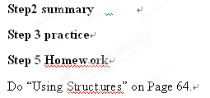

Step 1.Warming up
Read aloud to warm up: Let’s warm up by reading aloud to the recording of the text SHOWING OUR FEELINGS.
Step 2. Guided reading
1.Reading and translating
Read the text SHOWING OUR FEELINGS and translate it into Chinese paragraph by paragraph.
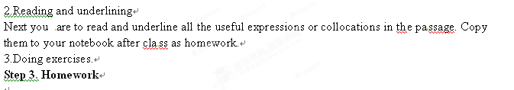

Teaching Goals:
- Enable the students to get as much information as possible about body language from the listening materials, meanwhile, train them for their listening comprehension as well as their memory to grasp the main ideas from the listening passages.
- Enable the students to improve their skills to get the key information and key words so that they may understand the stories better and fulfill the tasks more easily.
Teaching Procedures:
Step 1. Revision
Check the students' homework.
1. Go over the exercises on Pages 63- 65 together.
2. Revision of the reading, asking some more students to retell the text in their own words.
Step 2. Listening
(1) What Lin Pei says and does;
(2) What the cyclist says and does;
(3) What the policeman says and does.
Step 3. Act out the actions in the listening passage
After playing the tape once more.
you may use the following functional structures to help you: You may not... You should never ...
You must... Do not...
Never... Always stay ...
Be careful when ... Watch out... He must...
Step 4. Listening Task
Do Tasks 1 & 2. Let's read the requirements of the two exercises first.
Check the students' answers to the listening tasks after playing the tape two or three times.
